Bangs ‘N’ Botox Press Kit

Diane Dean-Epps, Author

1. Press Release
Laugh About Aging Until You STOP Crying!
Diane Dean-Epps Releases Bangs ‘N’ Botox: My Aging Journey Into, Through, and Beyond Denial, Fillers & Human Preservatives
FOR IMMEDIATE RELEASE
Grass Valley, CA, June 21, 2025 — Diane, a sharp-witted indie humorist, releases her latest book, BANGS ‘N’ BOTOX, a hysterically relatable take on growing older. With a tone that’s equal parts punchline and pep talk, Diane takes readers on a raucous ride through the quirks, annoyances, and ironies of aging.
Packed with humorous observations, pithy asides, helpful hints, and the occasional rant, BANGS ‘N’ BOTOX delivers rapid-fire laughs on everything from marginally successful skincare experimentation to the social art of making situations awkward.
Step into Diane’s laugh-lined world and experience her signature “sit-down standup” comedy writing style—a mix of wit, wisdom, and baby boomer bravado. With the life experience of an active senior and the comic timing of a pro, Diane makes aging more bearable—and a lot more fun.
Available now in paperback and eBook formats. For more information, visit Diane’s contact page on her website.
Contact:
Diane Dean-Epps
www.dianedeaneppswriting.com

2. Author Bio
As the creative mind behind her “sit-down standup” style of humor writing Diane Dean-Epps has proven that comedy is just as effective from a chair—preferably one with lumbar support and a cup holder—as it is from a standing position. Her humor has found a home in multiple books, including Bangs ‘N’ Botox: My Aging Journey Near, Through, and Out of Denial and Botox, Fillers, & Human Preservatives, the latter essential reading for anyone who’s ever looked in the mirror and gasped at what time hath wrought.

Diane’s career has offered up a bountiful buffet of opportunities—sometimes concurrently—in industries as diverse as media, education, marketing, entertainment, and fitness leading to incredible feats of multi-tasking. This explains her unique ability to deliver a punchline, grade essays, post social media updates, and draft stories as she voices commercials and assumes the plank position for one minute and 22 seconds.

Currently residing in northern California, Diane writes and performs in productions both planned and—much to the surprise of unsuspecting bystanders—unplanned. Her audiences are (mostly) entertained, and she considers that a solid win.

3. Book Summary
Pending the invention of a time machine, we’ll all have to make peace with aging. What better way to do it than by having some fun at aging’s expense? BANGS ‘N’ BOTOX, does just that…and so much more.
Diane offers a fresh and funny perspective on growing older by tackling hot-button issues like the dangers of sports bras that are alchemized into strait jackets when sweat is introduced into the mix and the fear social media instills in our citizens when the one who should have gotten away apparently hasn’t because they found you and “wonder how you’ve been?” She also talks about how different her glory days are from her golden years. This is aging with edge—and a lot of laughs.
A relative unknown, Diane jokes that she might end up the Emily Dickinson of humor—minus the cemetery proximity—with her fame arriving posthumously, if at all. Regardless, she soldiers on with gusto, delivering her fourth humor book and her most relatable work yet.
This 283-page, six-chapter, share-worthy big-time funny book will have you reading excerpts out loud to your friends and family. Aging has never been this relatable—or this comical.

4. Media Images
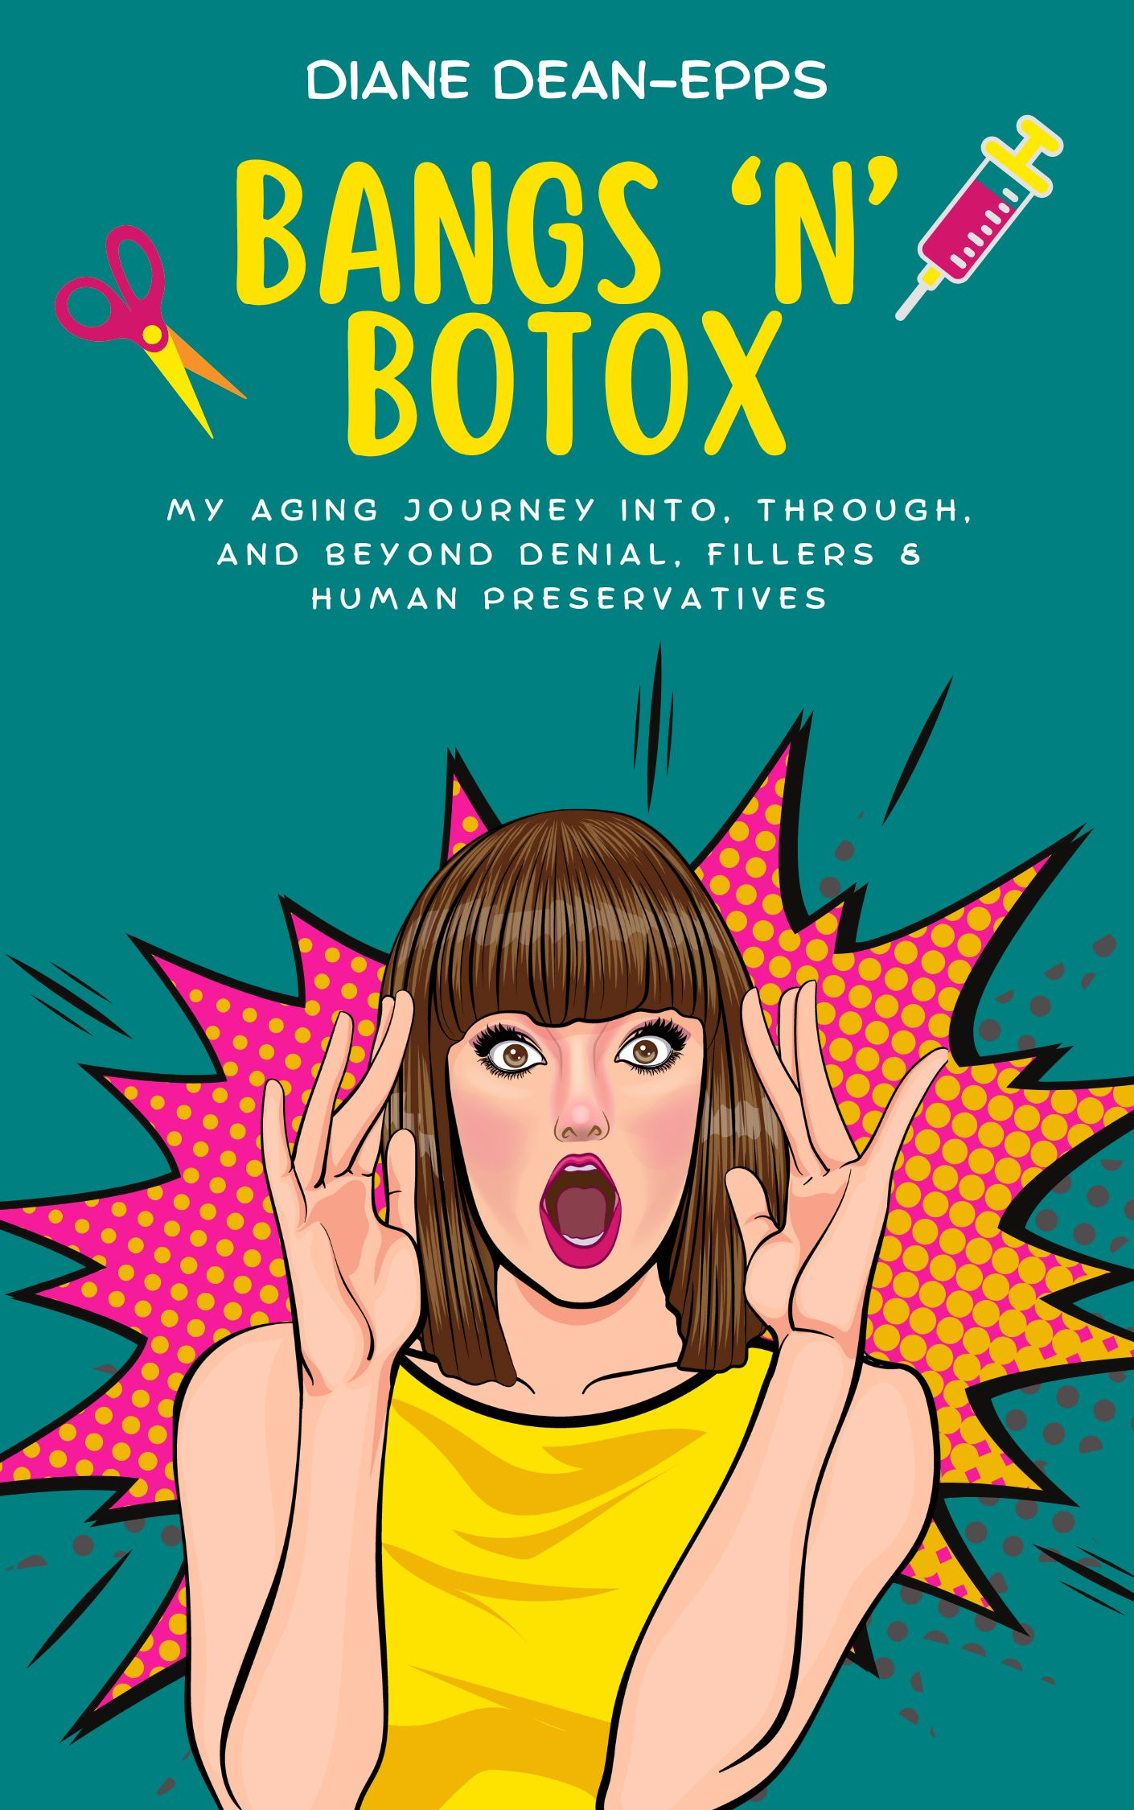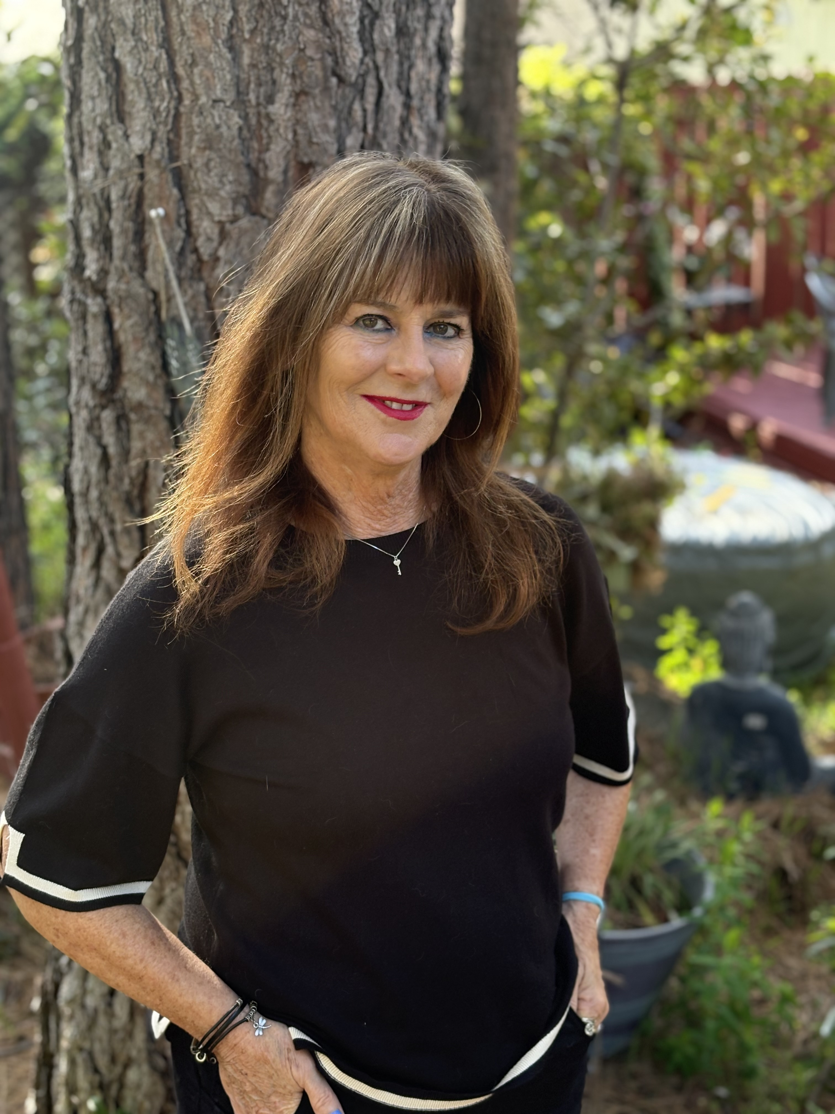
Book Cover (JPG) Author Photo (JPG)
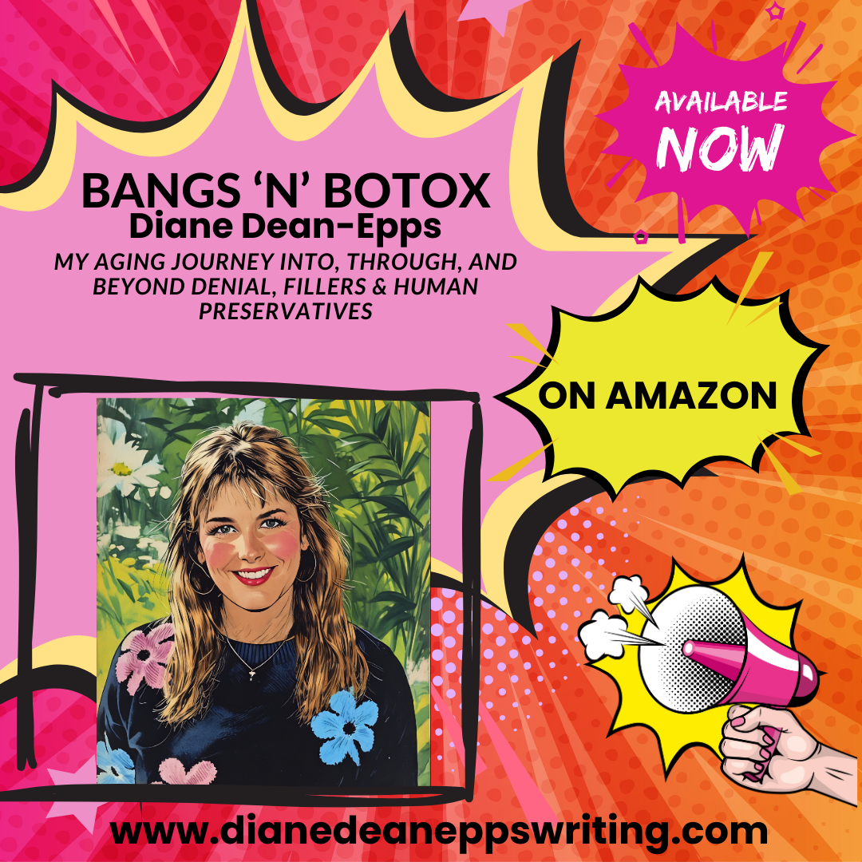
Promotional Graphic (PNG)

5. Suggested Interview Questions
1. What inspired you to take a comedic approach to aging in BANGS ‘N’ BOTOX?
2. How long have you been writing?
3. Do you write in other genres?
4. Who are your comedic influences?
5. How has your perspective on aging changed over time?
6. What is your favorite line, chapter, or topic from the book?
7. Do you see humor as a tool for coping with aging or as an act of rebellion?
8. Is there a takeaway or overarching theme from BANGS ‘N’ BOTOX?
9. How would you describe your "sit-down standup" style?
10. What’s next in your writing journey?

💉Bangs ‘N’ Botox – One-Page Media Sheet ✂️
📌 Quick Facts
Title: BANGS ‘N’ BOTOX
Author: Diane Dean-Epps
Genre: Humor / Aging / Essays
Format: Paperback, eBook
ISBN: 978-0981482934
Publisher: Hope Springs Eternal
Available: Amazon
🪝The Hook
Pending the invention of a time machine, we’ll all have to make peace with aging. Why not have some fun at its expense? BANGS ‘N’ BOTOX is your laugh-out-loud survival guide to growing older with grit, wit, and a lot of laughs.

📖 About the Book
With rapid-fire punchlines and a healthy dose of honesty, Diane takes you through the awkward, hilarious, and all-too-relatable experience of aging. Readers will laugh along as Diane recounts her marginally successful skincare experiments, her uncanny knack for making any situation awkward, and the stark (and hilarious) contrast between her glory days and her golden years. This is aging like you’ve never read it—sharp, funny, and unapologetically real.

👩‍🦳 ✏️About the Author
Diane is a humorist and the author of four humor books. Known for her “sit-down standup” style, she brings sharp wit, boomer wisdom, and fearless honesty to every page. Though she jokes she might end up the Emily Dickinson of humor—minus living next door to a cemetery—with her fame arriving posthumously, if at all, her work is made to be read, shared, and enjoyed—before or after death.
📞 Media Contact
Name: Diane Dean-Epps
Website: www.dianedeaneppswriting.com
Media History: See Press Page
Social Media Links
Facebook
Twitter
LinkedIn
Instagram
YouTube

